WEIGHING SCALE PRODUCT SELECTION
Equipment: SI-850 Weighing Scale
Purpose: To ensure the correct product is selected before starting weighing operations.

1. Purpose
To define the correct procedure for selecting a product/PLU on the weighing scale before weighing.

2. Scope
This SOP applies to all operators using the SI-850 weighing scale for product weighing.

3. Procedure

Step 1 – Normal Weighing Mode
When the weighing scale is switched ON, the scale will normally be in Weighing Mode.
The current weight will be displayed on the screen.
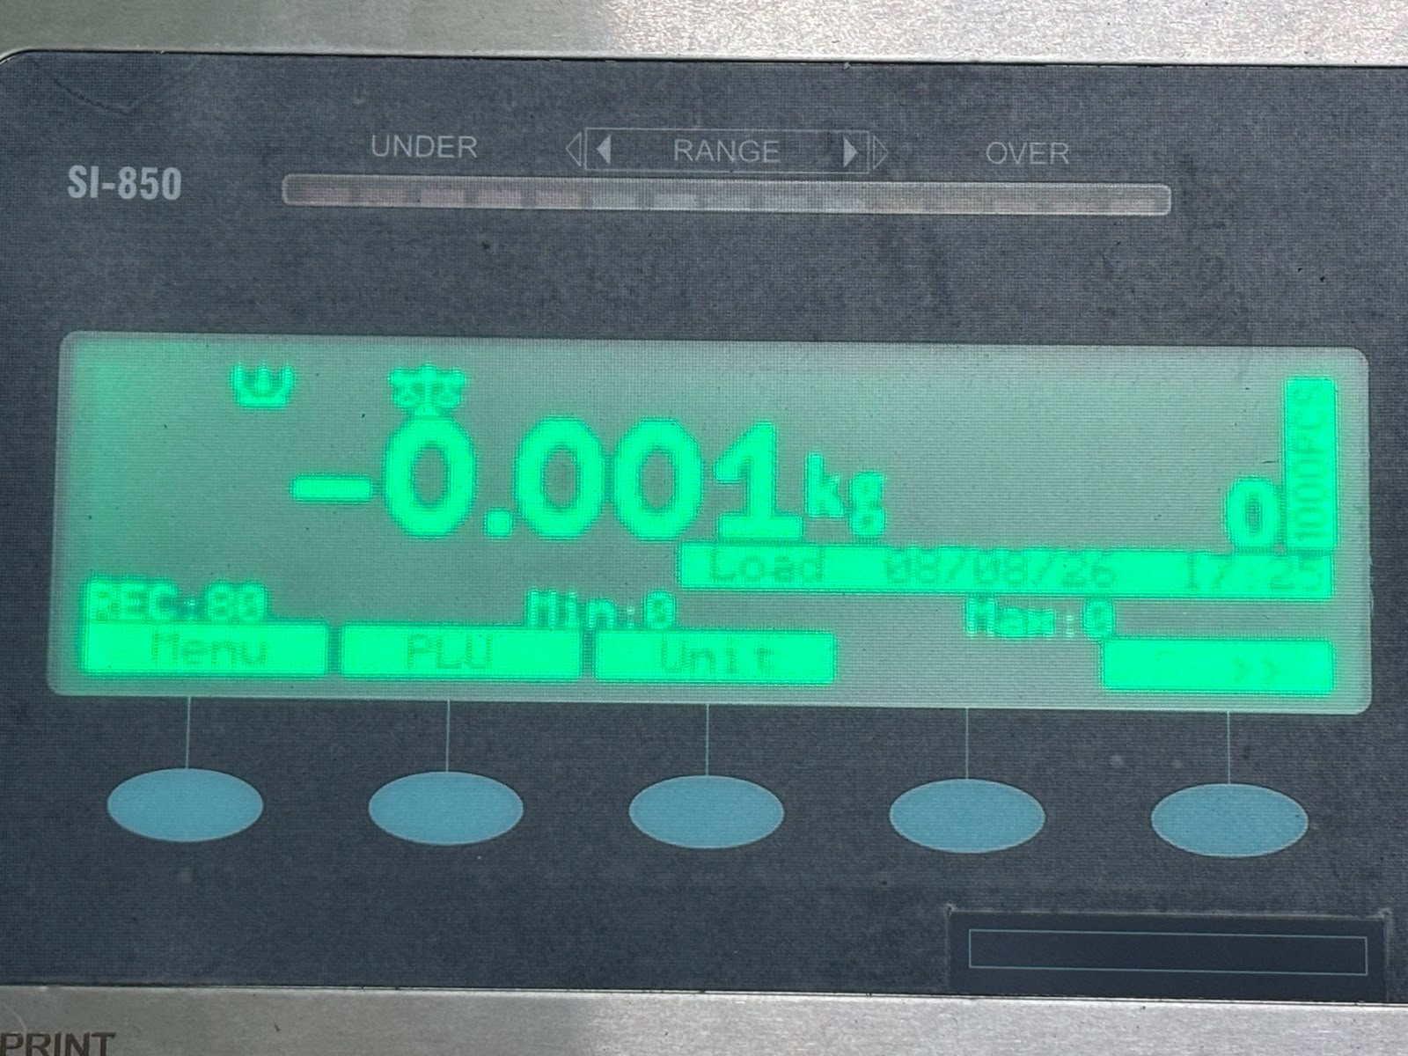

Step 2 – Enter Product Number
From the normal weighing mode, directly press the number at which the required product is saved.
Example:
If the required product is saved at PLU No. 17, press:
17

Step 3 – PLU Screen
After pressing the product number, the PLU screen will appear.
The screen will show:
“Enter PLU No./PCS/Tare kg”
The entered product number will also be displayed.
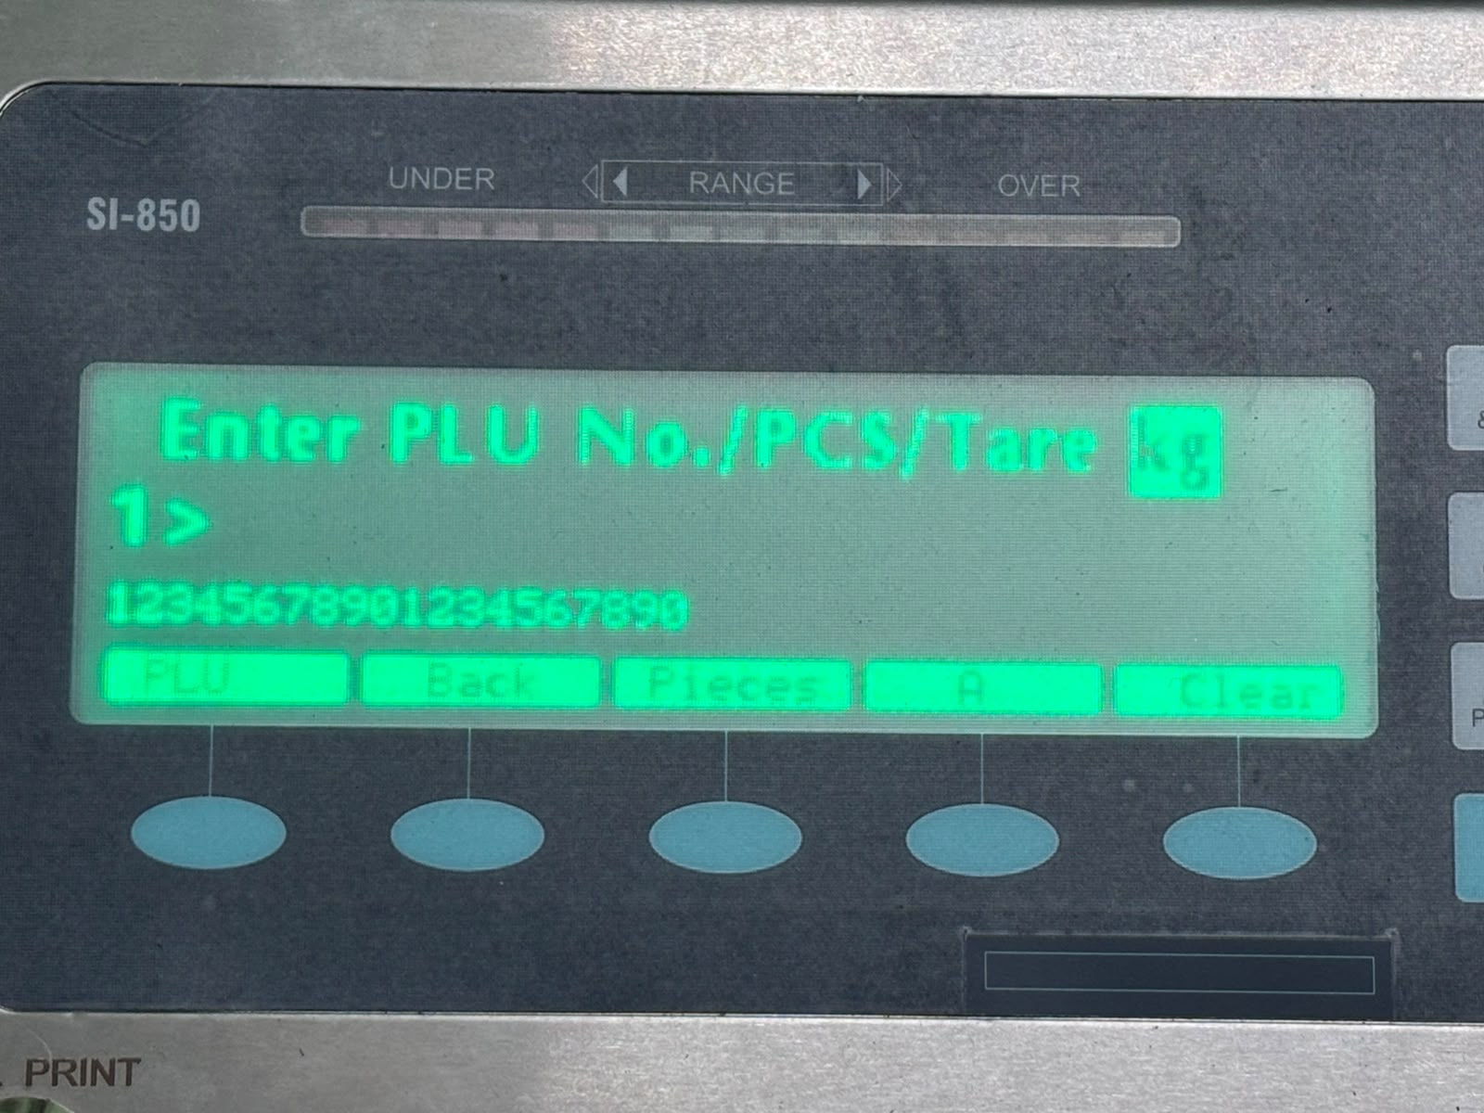

Step 4 – Confirm Product Selection
After entering the required product number, press the PLU button.
This will select the product.

Step 5 – Return to Weighing Mode
After pressing the PLU button, the weighing scale will automatically return to the Normal Weighing Mode.
The selected product is now active and weighing can be started.

4. Important Points
- Always select the correct PLU number before starting weighing.
- Verify that the correct product is selected before weighing.
- Do not start weighing if the wrong product has been selected.
- If the wrong product is selected, repeat the product selection procedure.
- The PLU number must correspond to the approved product master.

5. Quick Procedure
Normal Weighing Mode → Press Product Number → PLU Screen → Press PLU → Normal Weighing Mode

